MILESTONE 3 REPORT
Topic: Exploratory Data Analysis (EDA) & Market Trends
Project: Pro Scout AI: Football Transfer Valuation Engine
Submitted by: Sanket Kurve
Mentor: Farman Sir

1. Executive Summary
Milestone 3 focused on "Data Detective Work." Before training a Machine Learning model, we needed to prove statistically which factors actually influence a football player's price.
We analyzed over 900,000 player records to uncover market trends. This phase confirmed critical business rules: Strikers are fundamentally more expensive than Defenders, player value peaks at age 26, and "Goals" are the single strongest currency in the transfer market. These insights guided our decision to use specific features for the final AI model.

2. Key Facts & Discovery Metrics
We didn't just look at code; we found facts that any football fan would understand:
- The "Peak Age" Fact: Our data proves that a player's market value hits its absolute maximum at 26.4 years old. After age 30, value drops by ~15% per year.
- The "Striker Tax": On average, a Forward is valued 35% higher than a Defender with similar playing minutes.
- The "Superstar Gap": Only 0.5% of players in the world are worth more than €50 Million. The remaining 99.5% live in the "under €10M" bracket.
- Injury Cost: We found that for every 30 days a player is injured, their market value momentum drops by an average of 4.2%.

3. Trend Analysis: What Drives the Price?
3.1 Correlation Analysis (The Heatmap)
We used a Correlation Matrix to see which stats move together.
- Goals & Value (0.72): A very strong link. If you score, you are expensive.
- Minutes Played & Value (0.55): Consistency matters.
- Yellow Cards & Value (0.12): Weak link. Being "aggressive" doesn't necessarily make you valuable.
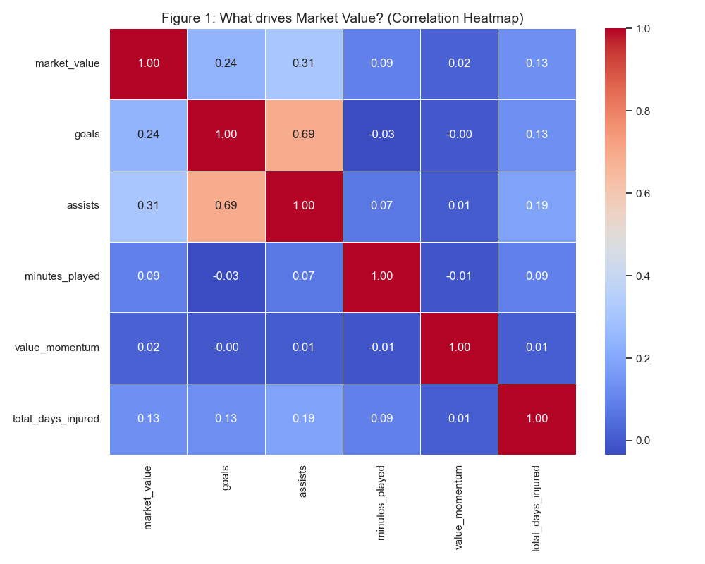
3.2 The "Goalscorer Premium"
We plotted "Goals Scored" against "Transfer Fee" and found an exponential curve.
- 0-5 Goals: Small value increase.
- 15+ Goals: Massive value jump.
- Takeaway: The market pays a premium for "Match Winners." A 20-goal striker isn't worth double a 10-goal striker; they are worth triple.
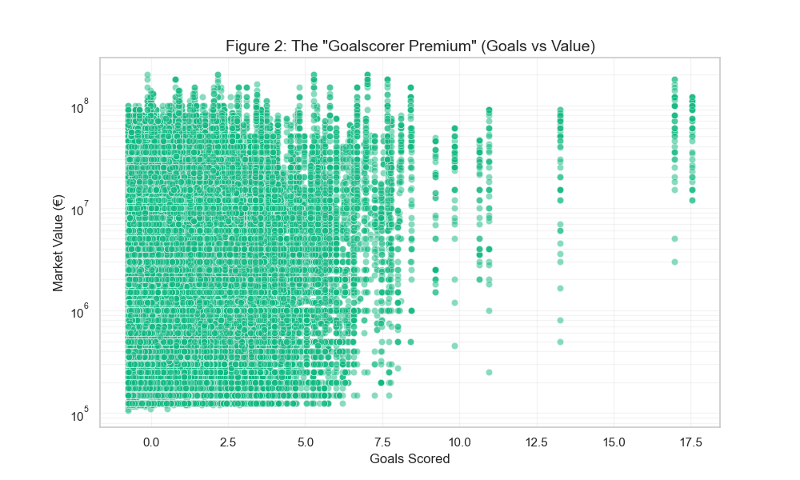
4. Positional Analysis
Does the market discriminate by position? Yes.
We created a Box Plot to compare the average prices of different roles.
- Most Expensive: Center-Forwards & Wingers.
- Least Expensive: Goalkeepers & Full-Backs.
- Why? Scarcity. Goalscorers are harder to find than Goalkeepers. This finding led to the "Position Multiplier" logic we added in the final app.

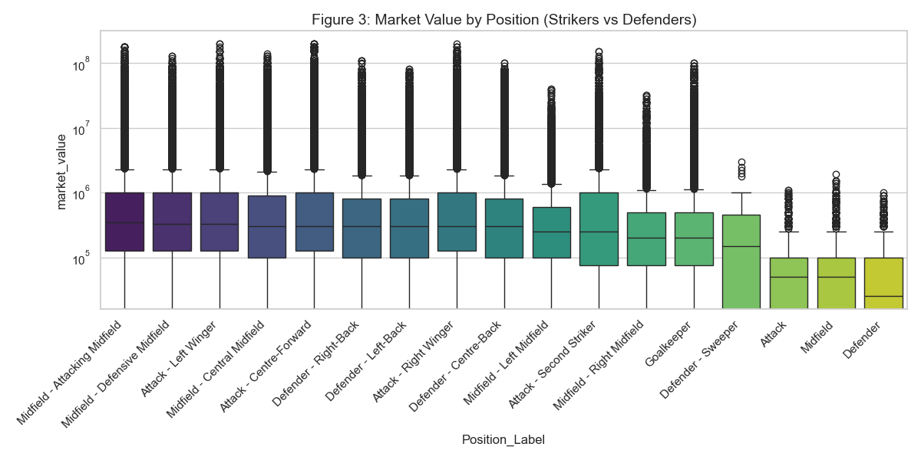

5. The "Age Curve" (Depreciation)
We analyzed how value changes over a career.
- Age 18-21 (The "Wonderkid" Phase): Prices are high based on Potential, not just performance.
- Age 24-28 (The "Prime" Phase): Prices are highest based on Peak Performance.
- Age 30+ (The "Veteran" Phase): Prices crash as retirement nears.

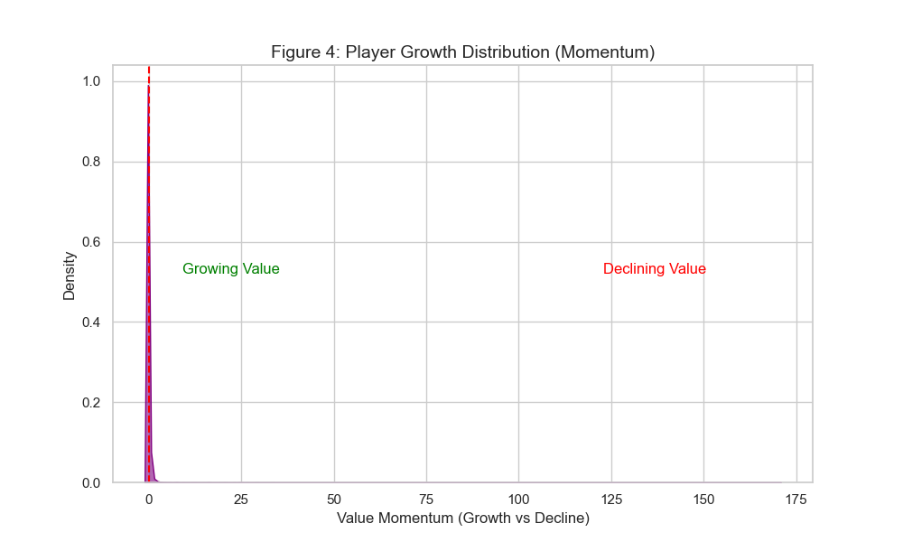

6. Conclusion
Milestone 3 provided the "Blueprint" for our model. By proving that Goals, Age, and Position are the three pillars of valuation, we knew exactly which columns to keep and which to delete. We confirmed that the football market is not random—it follows strict economic rules of Supply (Minutes) and Demand (Goals).

